Key points for students
To use Sketchpad to create a simple drawing navigate to
https://www.sketch.io/sketchpad/
There are a range of drawing tools available.
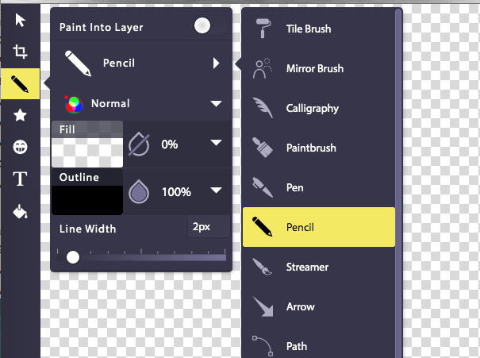
To use Canva to create an infographic you will need to create an account.
Navigate to https://www.canva.com/ to register.
Then, from the home screen navigate to templates, then to marketing and select the infographics option.
